Research Proposal Template

Seeking Novel Immune-Inflammatory Targets, Pathways, and Therapies

Almirall, S.A. are funding research projects up to €250k total funding per project based on their interest in the immune-inflammatory disease space, with a particular focus on dermatological indications. Please see a copy of the one-page campaign summary (i.e. Almirall, S.A.’s specific criteria for this Research Proposal) at the end of this document.

Project Title

Title should be no longer than 20 words.

Principal Investigator Contact Information

Name:
Title:

Email:

Phone:

Institution, Department, and Address:

Abstract

Please provide a summary of the research proposal, including: the overall goal; hypothesis; specific aims; clinical rationale; commercial potential (if known); and what is novel and innovative about your approach.

Abstract should be no longer than 250 words.

Therapeutic Opportunity Description

- What is the primary therapeutic area?
Highest priority indications are as follows:
Dermatology: atopic dermatitis; alopecia areata; Bulloid pemphigus; chronic eczema; Dermatomyositis; Erythema nodosum; Epidermolysis bullosa; Hydradenitis suppurativa; Lichen planus; Pemphigus vulgaris; Psoriasis; Pyoderma gangrenosum; Scleroderma; Vitiligo

Other chronic immune-inflammatory diseases to be considered for new targets, pathways and therapies
Gastrointestinal: Crohns’ disease; ulcerative colitis
Neurology: Multiple sclerosis
Musculoskeletal disorders: ankilosing spondilytis; juvenile idiopathic arthritis; polymyalgia rheumatica; Psoriatic arthritis; Reumathoid arthritis; Systemic lupus erythematosus
Respiratory: Asthma; Sarcoidosis

- What is the development stage? Please choose from: Discovery, target identification, target validation, hit generation, compound screening, lead generation, in vitro, in vivo, or preclinical validation.

- What is the therapeutic modality (if any)?
- Have you developed experimental models to support the research? Please include details on: the type of model (in-vitro/in-vivo/ex-vivo etc.); and species (mouse, human-mouse, rat, etc.). Please also provide a brief description of the model, and the following, if applicable: similarities or differences to human pathology; possible limitations of the model; and key advantages over alternative models available.

- Please provide a brief description of the target/pathway and its link to human disease. For a list of already known (i.e. lower priority targets), please see appendix 2 of this document.

- Please describe any therapeutic candidates the investigator has generated against the target, including the mechanism of action. Include the known characteristics of the therapeutic candidate (such as affinity, specificity, potency, pharmacokinetics, etc.) If unavailable, please describe the preferred attributes of the therapeutic candidate.

Scientific Background and Rationale

- Please summarise the hypothesis, background science and rationale, work completed to date, and current stage.

- Please provide key evidence/data to support the hypothesis. This may include human genetics, human tissue, in vivo models, and preclinical proof of concept.

Research Plan and Milestones

Please provide a brief description of the research plan to be carried out to reach your goals. This should include your objectives and specific aims.

Budget, Resources, and Funding

Awardees can request up to €250k total funding per project, through a Sponsored Research Agreement. This includes all expenses and indirect costs, etc. Term of funding should not exceed 2 years.

With this in mind, please could you specify what the award money would be spent on?

IP and Legal Considerations

- Have you previously disclosed this technology to your technology transfer office?
1.a If yes, who is your Case Manager? Please include their email address.

- To the best of your knowledge, what is the prior art in this space? This could include publications, patent applications, and issued patents.

Research Team

- Please provide a brief biographical sketch of the principal investigator and a list of his or her key publications. An NIH format biosketch is acceptable.

- Please list other team members (if any), including collaborators, and describe their roles in the project. Please provide a brief biographical sketch of the co-investigators (including Title, Department, and Institution).

Submitting this Research Proposal

Once filled out, please submit this form using the following method:

- For universities subscribed to IN-PART and using the dashboard, please simply upload this document as a ‘Research Project’ under the correct ICO.
- For anyone else, please simply email a copy of this document to discover@in-part.co.uk

If you have any questions regarding filling out or submitting this Research Proposal Template, or any other aspect of the Discover process, please do not hesitate to reach out to discover@in-part.co.uk. Additionally, answers to university FAQs can be found here.

Thank you for participating in this particular Discover call! We will keep you updated on the status of this submission.

Appendix 1 – Seeking Novel Immune-Inflammatory Targets, Pathways, and Therapies

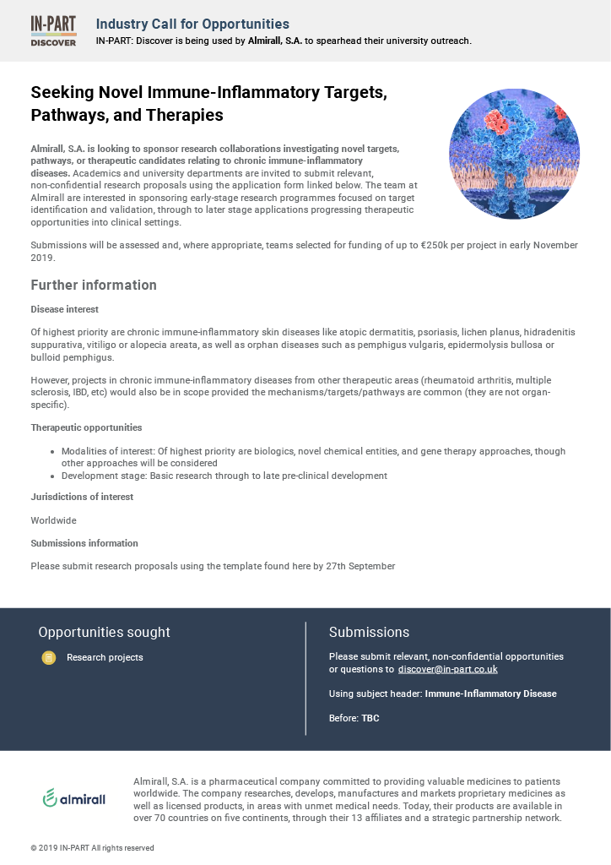

Appendix 2 – Already known (i.e. lower priority) targets
5-HT1A receptor  5-HT2B receptor  Aryl hydrocarbon receptor (Ahr)  Calcineurin pathway  Cannabinoid receptor (agonist target)  CD11a/CD18 (LFA-1)  Chemokine receptors  Chymase(s)  Cycloxygenases (COX1 and COX2)  Dihydroorotate dehydrogenase (DHODH)  E,L,P selectins  Galectin 3  GATA3  Glucocorticoid receptor (agonist target)  Histamine receptors (H1 to H4)  Inosine monophosphate dehydrogenase (IMPDH)  Integrins  Interferon gamma receptor (agonist; IFN-g)  Interferon gamma receptor (agonist; IFN-g)  Interleukins: IL-5, IL-12, IL-13, IL-17, IL-23, IL-33, or their receptors  Irak4  Itk  JAK1, 2, 3  Leukotriene pathways (synthesis of LTB4, LTC4 and their receptors)  Liver X Receptor (LXR)  Neurokinin 1 receptor (NK1R)  Neutrophil elastase  NFkappaB pathway  Nitric oxide synthase (NOS)  Opioid receptors (kappa, mu, delta)  OX40/OX40L  P2X's | P38 mitogen-activated protein kinases (P38)  PAR-2  phosphatidylinositol 3-kinase (PI3K)  phosphatidylinositol 3-kinase/protein kinase B pathway (PKB or Akt)  Phosphodiesterase 4 (PDE4)  Phospholipase A2 (PLA2)  Platelet activating factor receptor (PAFR)  Prostaglandin D2 receptors (DP1, Crth2)  Prostaglandin E receptors (EP1,2,3,4)  Retinoic acid receptors (RAR)  RoRgT  Sphingosine 1 phosphate receptor (S1PR)  Thymic stromal lymphopoietin (TSLP)  TNF-alpha  Toll like receptors  TrkA  Tyk2  Vanilloid VR1 Receptor (TRPV1)

